Project Design Phase-II
Technology Stack (Architecture & Stack)

Date | 19 February 2026
Team ID | LTVIP2026TMIDS89796
Project Name | Heritage Treasures: An In-Depth Analysis of UNESCO World Heritage Sites in Tableau
Maximum Marks | 4 Marks

Technical Architecture:
The Deliverable shall include the architectural diagram as below and the information as per the table1 & table 2
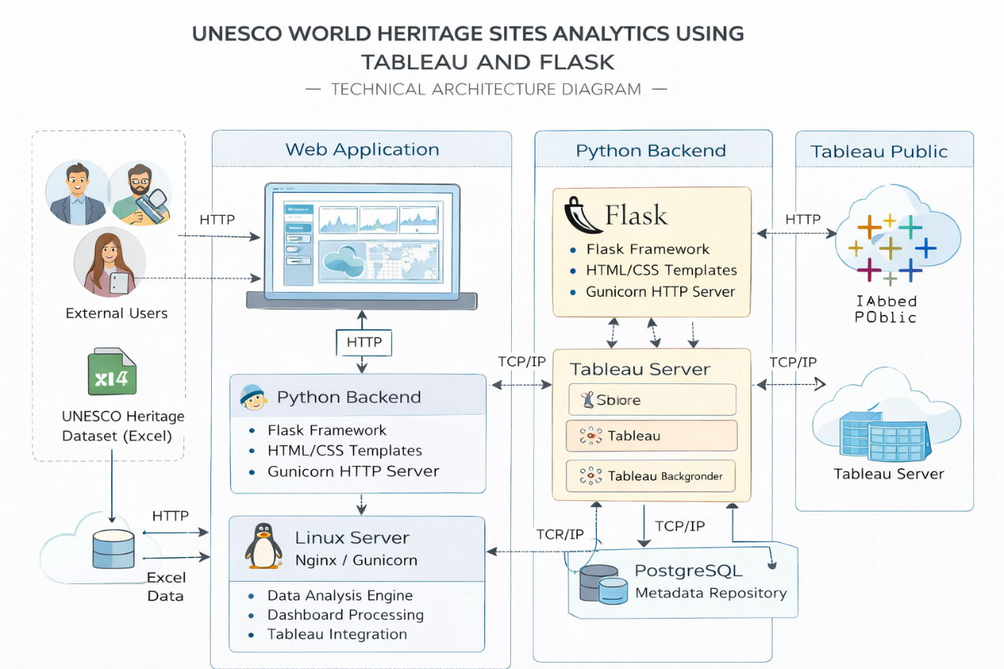
Fig: Technical Architecture

Table 1:

S.No | Component | Description | Technology
1 | User Interface | Web interface where users interact with dashboards and project stories | HTML, CSS, JavaScript
2 | Application Logic-1 | Backend logic to load templates, routing, and server execution | Python (Flask Framework)
3 | Application Logic-2 | Data visualization and analytics processing | Tableau Desktop
4 | Application Logic-3 | Dashboard embedding and interactive storytelling | Tableau Public (Embed Integration)
5 | Database | Heritage dataset used for visualization and analysis | Excel Dataset (UNESCO Data)
6 | Cloud Database | Hosting platform for dashboards and analytics | Tableau Public Cloud
7 | File Storage | Storage of project files, templates, and static resources | Local File System
8 | External API-1 | Visualization embedding service used inside web application | Tableau Public Embed API
9 | External API-2 | Web browser rendering and HTTP communication | HTTP/HTTPS Web Protocol
10 | Machine Learning Model | Not implemented in current project (Future Enhancement Scope) | —
11 | Infrastructure (Server / Cloud) | Application deployment environment | Local Flask Server (127.0.0.1), Future Cloud Deployment Possible

Table 2: Application Characteristics
S.No | Characteristics | Description | Technology
1. | Open-Source Frameworks | The project uses open-source web frameworks to build and run the application interface and backend logic. | Python Flask, HTML, CSS, JavaScript
2. | Security Implementations | Secure embedding of Tableau dashboards, controlled routing in Flask, and safe hosting through Tableau Public. | Flask Routing, HTTPS (Tableau Public), Basic Web Security Practices
3. | Scalable Architecture | The system follows a layered architecture where dashboards, web application, and data source are separated, allowing easy addition of new dashboards. | Flask Framework, Tableau Public Integration
4. | Availability | The application remains available whenever the local Flask server is running and dashboards are accessible through Tableau Public cloud hosting. | Local Flask Server, Tableau Public Cloud
5. | Performance | Lightweight Flask backend and optimized Tableau dashboards ensure smooth loading and responsive interaction for users. | Python Flask, Tableau Visualization Optimization

